**RCCG OGUN PROVINCE 20**

**in collaboration with**

**EDEN FOUNDATION**

**WOMEN EMPOWERMENT PROGRAMME**

**Sunday, January 21, 2024**

**List of Awardees**

|  |  |  |
| --- | --- | --- |
| **S/N** | **Name** | **Item** |
| **Fashion Designers** | | |
| 1 | Mrs Esther Ayinde | Sewing Machine |
| 2 | Mrs Akinbi Victoria | Sewing Machine |
| 3 | Mrs Yusuf Esther | Sewing Machine |
| 4 | Mrs Christiana Oluwapelumi | Whipping Machine |
| 5 | Mrs Aina Oluwagbemisola | Whipping Machine |
| **Traders** | | |
| 6 | Mrs Elegbede Abigail Adeola | Bag of Garri |
| 7 | Mrs Comfort Nene Adewale | Provision |
| 8 | Mrs Aremu Elizabeth | 25 Litres of Palm Oil |
| 9 | Mrs Osas Sandra Collins | Bag of Garri and 10 Crates of Egg |
| 10 | Mrs Abosede Abidemi Abiodun | 25 Litres of Engine Oil |
| 11 | Mrs Abiodun Taiwo Bolanle | 75 Litres of Liquid Soap |
| 12 | Mrs Joy Hart | 75 Litres of Liquid Soap |
| 13 | Mrs Elizabeth Funmilayo Fatoki | 75 Litres of Liquid Soap & 25 Litres of Izal |
| **Caterers** | | |
| 14 | Mrs Omolola Bright Ikotun | Single-Step Local Oven |
| 15 | Mrs Faith Ibhagbemen Aroviathe | Single-Step Local Oven |
| 16 | Mrs Salome Happiness Odeh | 50kg of Mama Gold Flour and 10 Litres of Vegetable Oil |
| 17 | Mrs Abosede Arinola Adedapo | Popcorn Machine |
| 18 | Mrs Abiola Omowunmi Amusan | Cake Mixer |
| **Training** | | |
| 19 | Mrs Abiodun Elizabeth Ipereolu | Enrolment for Hairdressing Training |
| **Agriculturist** | | |
| 20 | Mrs Sarah Damilola Boluwarin | Fish-Farming – Fingerlings & Feeds |

**PHOTO GALLERY**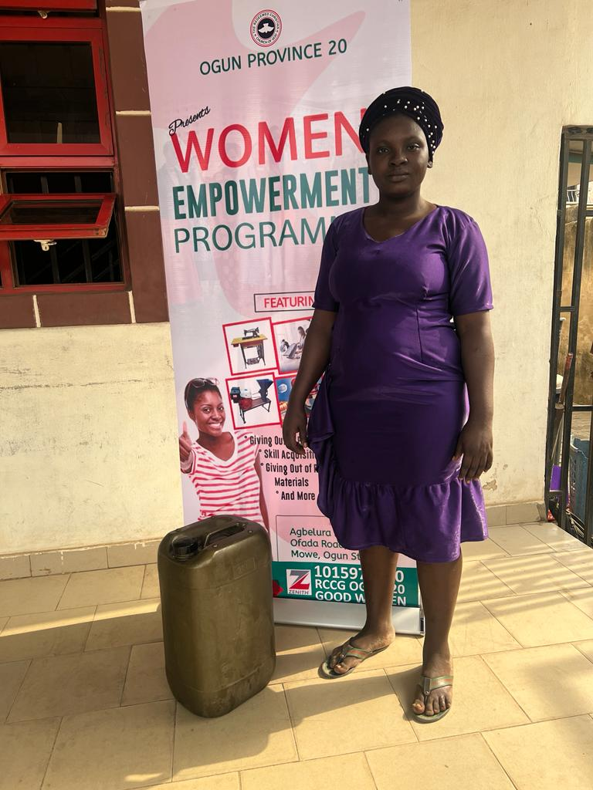

Abiodun Abosede – 25 litres of engine oil

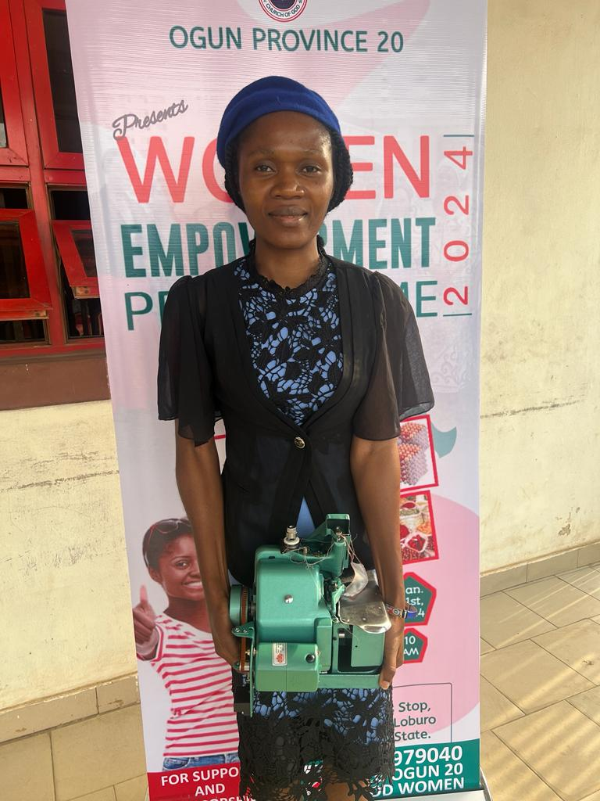

Aderehinwo Christianah Oluwapelumi – Whipping Machine

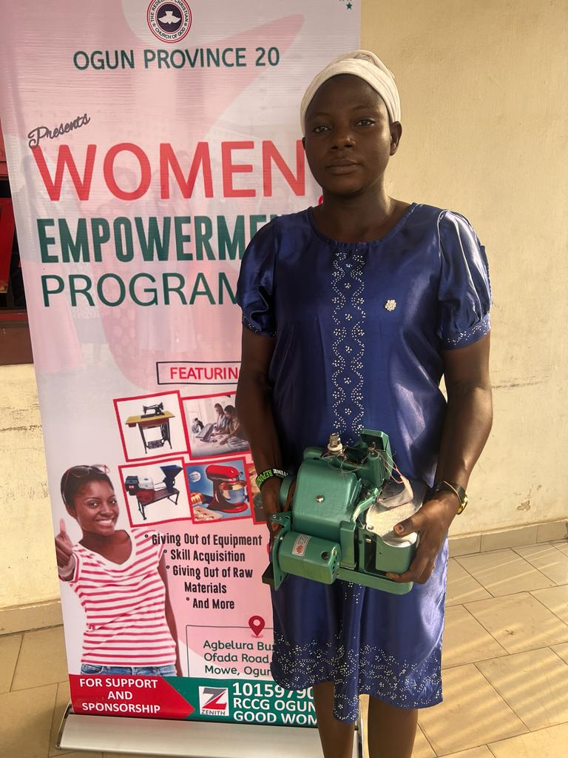

Aina Oluwagbemisola Abidemi – Whipping Machine

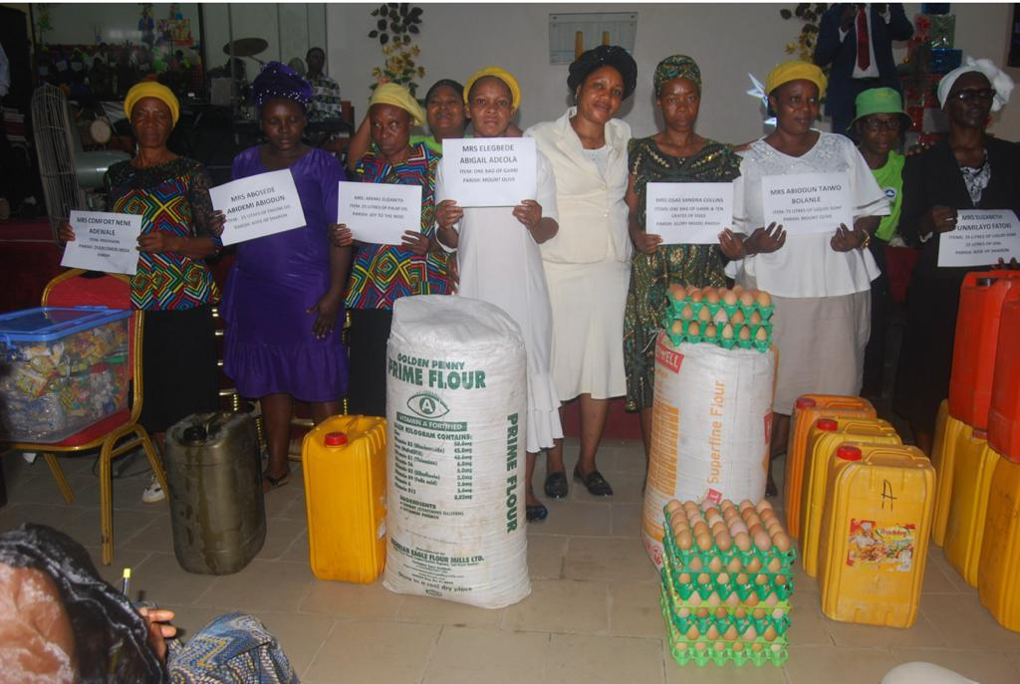

A Cross-section of Beneficiaries at the Empowerment Programme

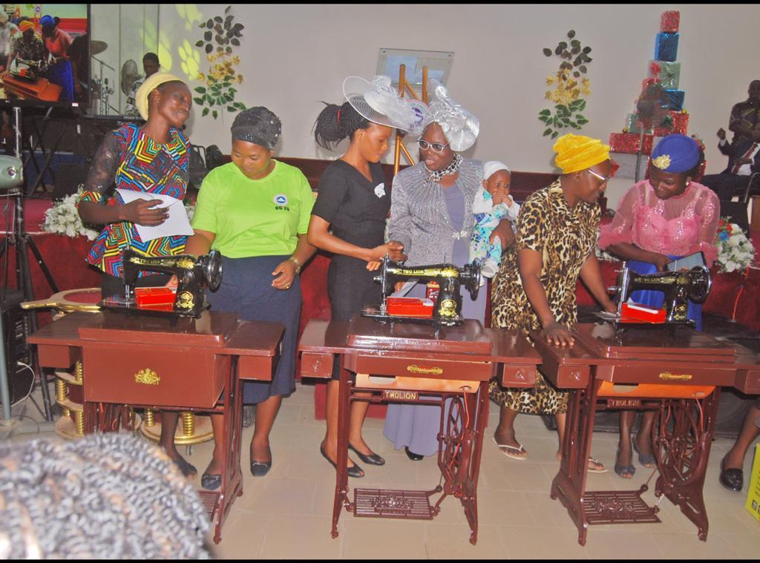

From left to right - Mrs Esther Ayinde (Sewing Machine), Mrs Akinbi Victoria (Sewing Machine) and Mrs Yusuf Esther Fatimot (Sewing Machine)

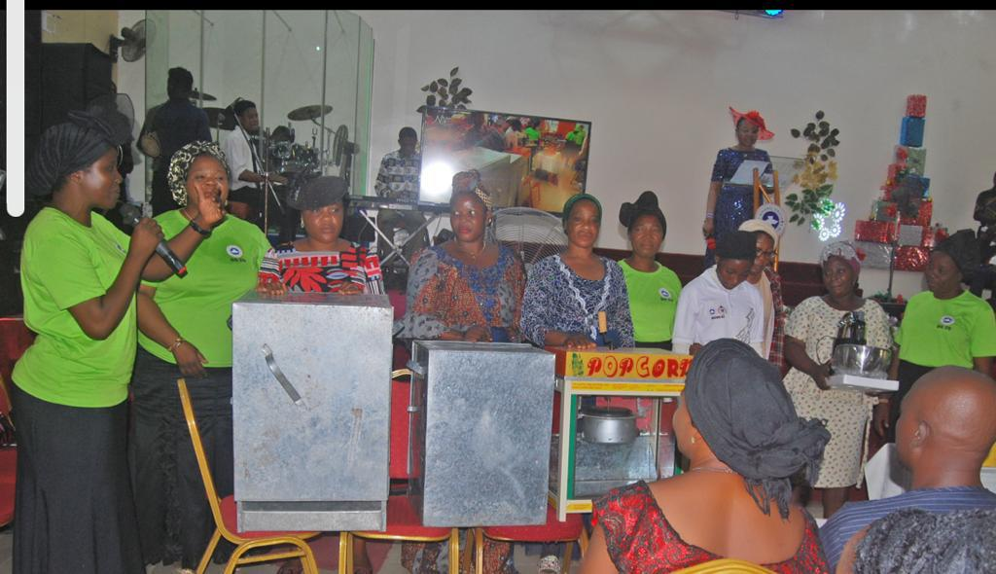

From left to right - Mrs Faith Ibhagbemen Aroviathe (Single Step Local Oven), Mrs Omolola Bright Ikotun (Single Step Local Oven), and Mrs Abosede Arinola Adedapo (Popcorn Machine)

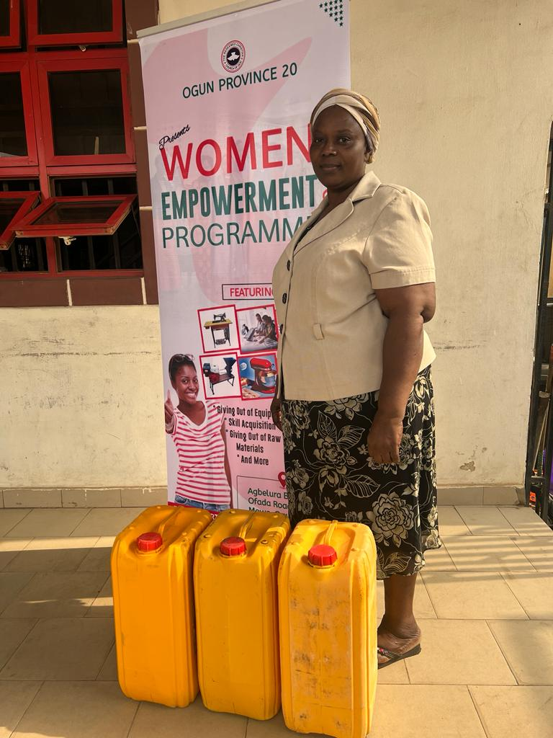

Mrs Abiodun Taiwo Bolanle - 75 Litres of Liquid Soap

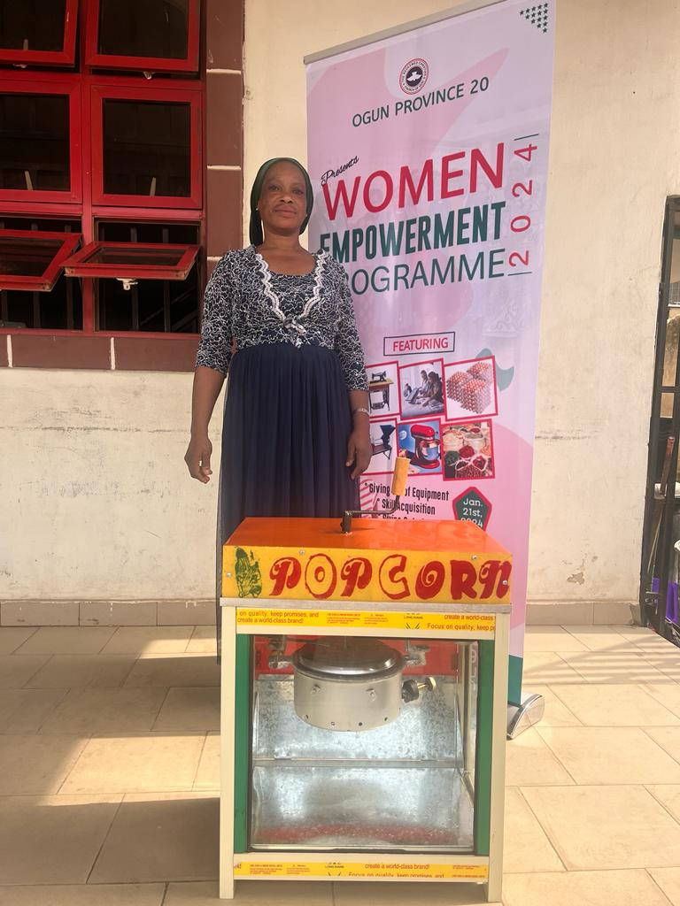

Mrs Abosede Adedolapo - Popcorn Machine

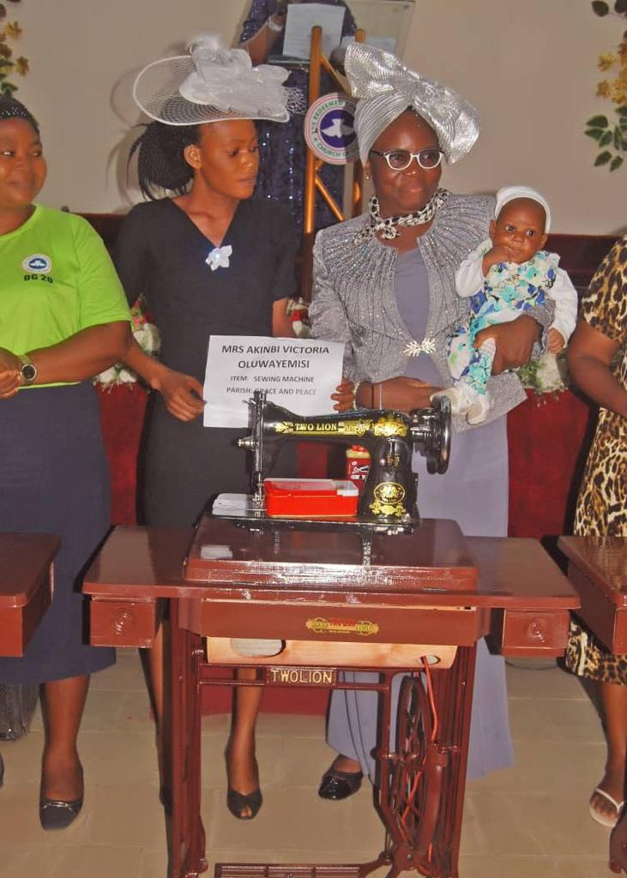

Mrs Akinbi Victoria Oluwayemisi - Sewing Machine

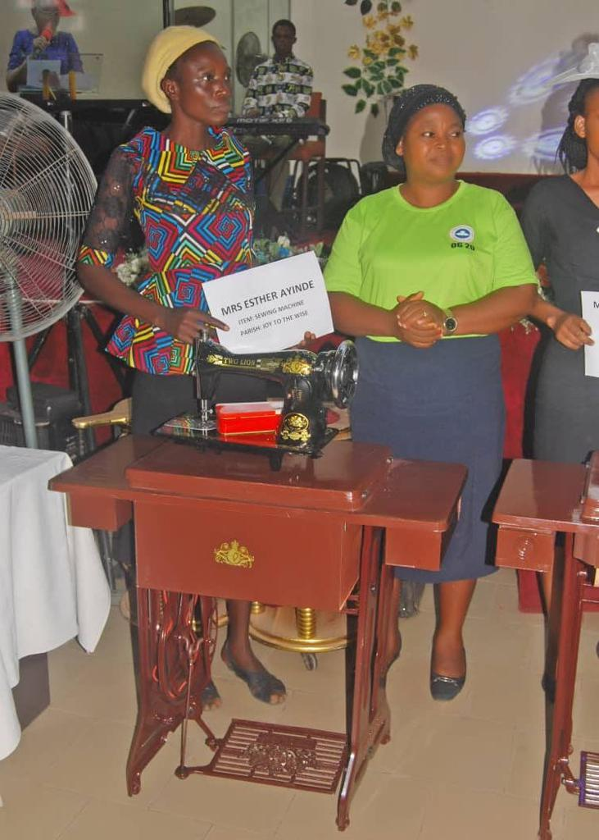

Mrs Esther Ayinde - Sewing Machine

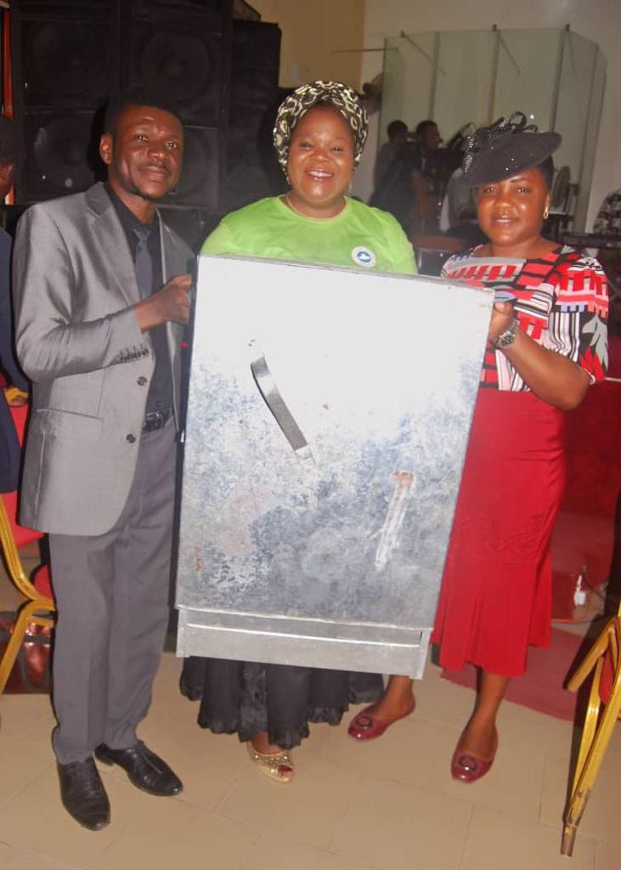

Mrs Faith Ibhagbemen Aroviather - Single Step Local Oven

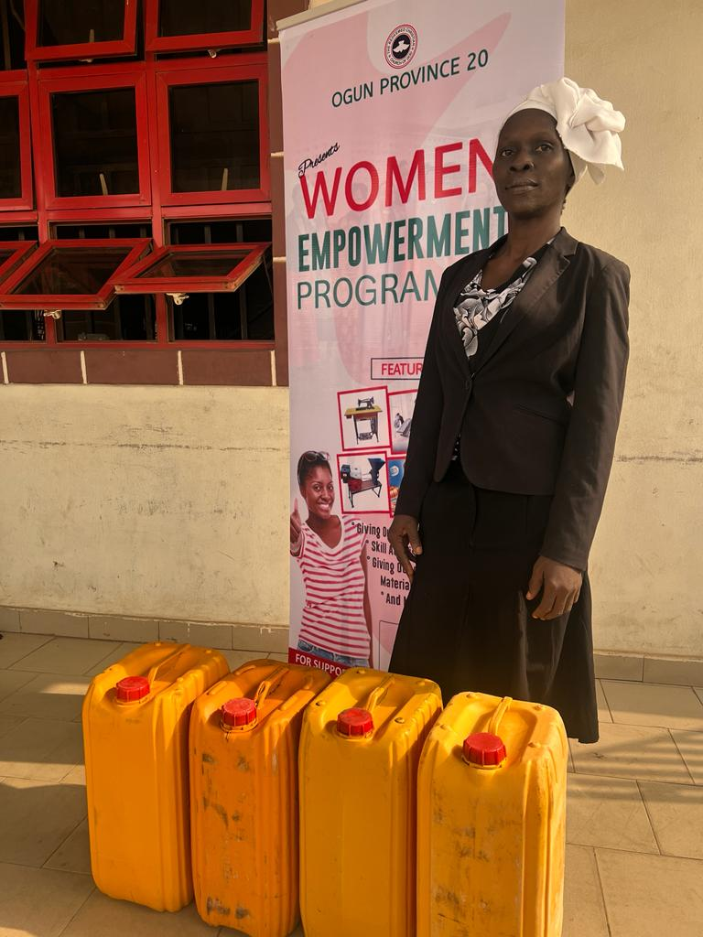

Mrs Funmilayo Fatoki - 75 Litres Litres of Liquid Soap and 25 Litres of Izal

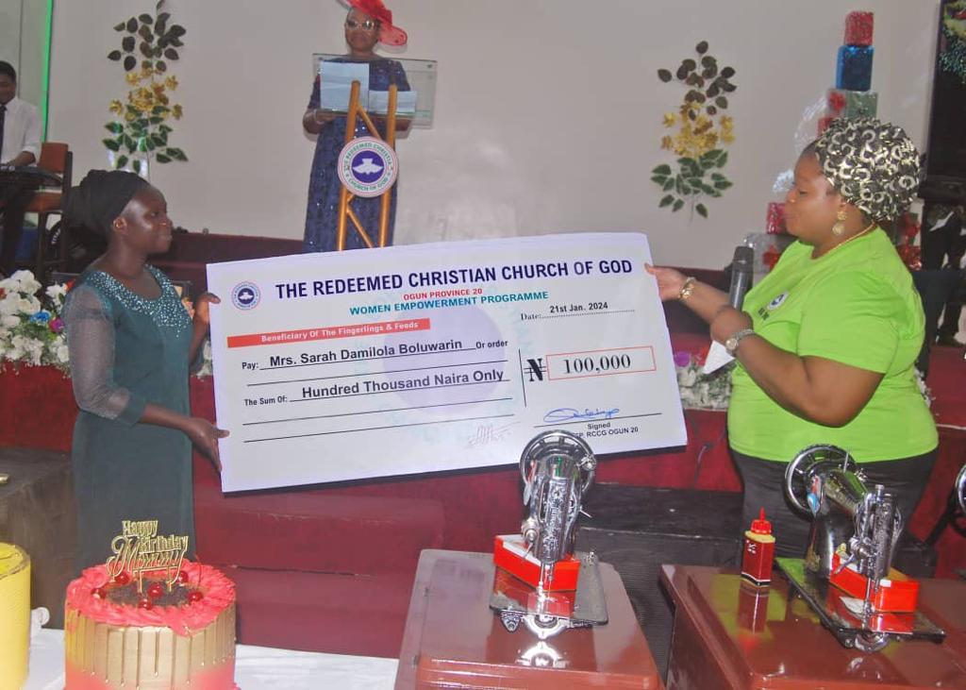

Mrs Sarah Damilola - Boluwatife Fingerlings and feeds - #100,000

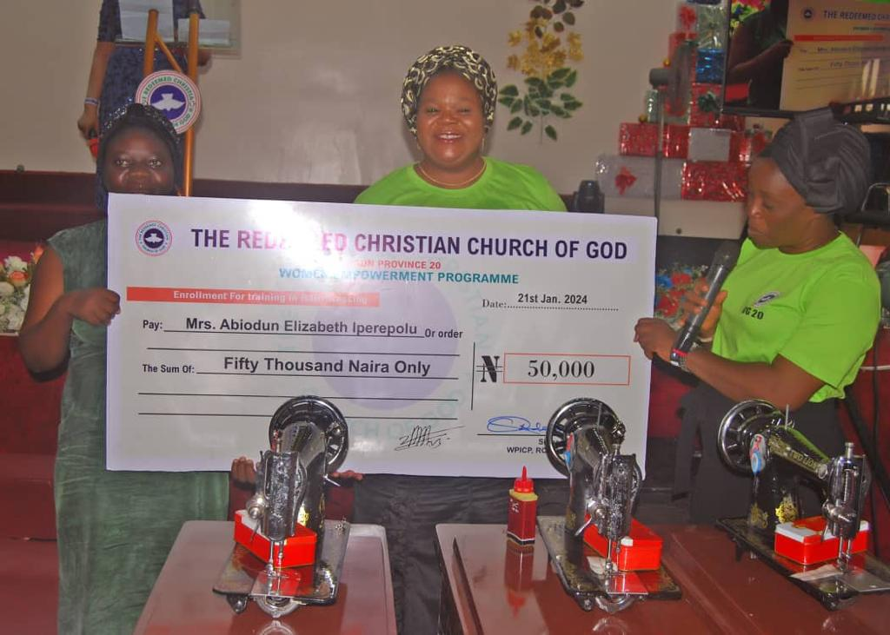

Mrs. Abiodun Elizabeth Iperepolu – Enrollment for training in Hair Dressing - #50,000

**LIST OF CASH DONATIONS**

|  |  |  |
| --- | --- | --- |
| **S/N** | **Donors** | **Amount** |
| 1 | Pastor Mrs Wonuola Adetayo | N175,000 |
| 2 | Pastor Mrs Adepeju Adekunle | N150,000 |
| 3 | Pastor Mrs Dare Ajayi | N10,000 |
| 4 | Pastor Mrs Popoola | N100,000 |
| 5 | Mrs Ruth Chukwu | N50,000 |
| 6 | Mrs Rosemary Ogwo Ifeoma | N25,000 |
| 7 | Mrs Ogwu Rosemary | N30,000 |
| 8 | Mrs Adewunmi | N5,000 |
| 9 | Mrs Rabiu | N10,000 |
| 10 | Mrs Kalejaye | N25,000 |
| 11 | Mrs Olu Olofin | N22,000 |
| 12 | Mrs Adeyemi Emily | N5,000 |
| 13 | Mrs Omotayo | N5,000 |
| 14 | Pastor & Pastor (Mrs) Ogwu | N25,000 |
| 15 | Mrs Opeyemi Ajayi | N15,000 |
| 16 | Mrs Adetayo Adetola | N50,000 |
| 17 | Mrs Ajimoti Funmilayo | N50,000 |
| 18 | Akinsola Atinuke | N50,000 |
| 19 | Derek Ibeagba | N108,000 |
| 20 | Mrs Adeife | N30,000 |
| 21 | Anonymous | N100,000 |
| 22 | Anonymous | N100,000 |
| 23 | Charles Ojo | N20,000 |
| 24 | Joy to the Wise Area | N15, 000 |
|  | **Total** | **N1,175,000** |

**LIST OF ITEMS DONATION**

|  |  |  |
| --- | --- | --- |
| **S/N** | **Donors** | **Amount** |
| 1 | Pastor Mrs Dele Oke | 1 Bag of Garri |
| 2 | Area Pastor (Mrs) Owatti | 1 Bag of Garri and 10 Crates of Eggs |
| 3 | Sister Bukola | 1 Single-Step Local Oven |

**ESTIMATION LIST**

|  |  |  |  |  |
| --- | --- | --- | --- | --- |
| **S/N** | **Items** | **Qty.** | **Amount Budgeted** | **Amount Purchased** |
| 1 | Sewing Machine | 3 | @N75,000 = N225,000 | N288,000 |
| 2 | Local Oven | 2 | @N50,000 = N100,000 | N144,000 |
| 3 | Whipping Machine | 2 | @N60,000 = N120,000 | N152,000 |
| 4 | Popcorn Machine | 1 | @N75,000 = N75,000 | N85,000 |
| 5 | Liquid Soap | 3 | @N25,000 = N75,000 | N66,544 |
| 6 | Cake Mixer | 1 | @N50,000 = N50,000 | N30,000 |
| 7 | Flour And Vegetable Oil | 1 | @N50,000 = N50,000 | N43,500 (Flour)  N36,000 (Veg. Oil)  = N79,500 |
| 8 | Engine Oil | 1 | @N38,000 = N38,000 | N44,000 |
| 9 | Palm Oil | 1 | @N27,000 = N27,000 | N27,000 |
| 10 | Provision | 1 | @N50,000 = N50,000 | N33,300 |
| 11 | Fingerling and Feed | 1 | @N100,000 | N100,000 |
| 12 | Hairdressing | 1 | @N50,000 | N50,000 |
| 13 | Garri and Eggs | 1 | @N50,000 | Items Given |
| 14 | Garri | 1 | @N50,000 | Items Given |
| 15 | Transportation by Mrs Bukola |  |  | N15,000 (@2 Times) = 30,000 |
| 16 | Machine Engineer |  |  | N8,000 |
| 17 | Banner |  |  | N8,000 |
| 18 | Dummy Cheque |  |  | N14,000 |
| 19 | Photography |  |  | N10,000 |
|  | **Total** |  |  | **N1,169,344** |

Analysis:

Total Income: **N1,175,000**

Total Expenditure: **N1,169,344**

Available Income: **N5,656**